Registration Application Form
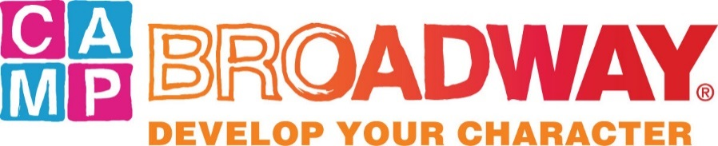

at The Vets
One Avenue of the Arts, Providence, RI
August 10-14, 2015

For Moms and Dads:
Please fill out this form and send it along with the attached Camper info sheet and your child’s photograph to:
Cynthia Goldsmith
Providence Performing Arts Center
220 Weybosset Street
Providence, RI 02903

Child’s Name _________________________________Age as of 8/1/15________Male___ Female __
Address________________________________________________________________________
City __________________________State ____ Zip______ Home Telephone (____)____________
Parent E-mail _____________________________Child E-mail______________________________
School _______________________________________________ 2015-2016 Grade ___________
Any dietary restrictions (i.e. vegetarian) or food allergies?__________________________________
Parent/Guardian Name ____________________________________________________________
Cell phone (____)______________________ Office Telephone (____)____________________
Child’s Nickname (if any): ___________________________________________________________
How do you want your child’s name to
read on their name tag and photo caption?_______________________________________________
Camper T-shirt size (circle one): Youth L Adult S Adult M Adult L Adult XXL

Camp Broadway costs $650.00 per child; applications will be accepted on a first-come, first-served basis. Applications must be accompanied by a non-refundable deposit of $350.00. The balance of $300.00 must be received within 60 days.

Payment enclosed: Checks should be made payable to Providence Performing Arts Center
Amount $________ Check _____ American Express _____ MasterCard _____ Visa _____
Account No. _________________________________________ Exp. Date _______ CID* _______
Billing Address____________________________________________________________________
Name as listed on card: _____________________________________________________________
Signature ______________________________________________ Date __________________

For Campers:

Your Name

Please tell us a little about yourself and send this form with the application.

Do you play a musical instrument or take any classes in the performing arts?
Yes _____ No _____ If yes, describe your activities.

Have you been involved in a play or musical in your school or community theater?
Yes _____ No _____ If yes, describe your activities.

What area(s) of the performing arts (e.g. drama, dance, vocals, costume or scenery design, stage management, choreography, etc.) are you most interested in learning about?

Have you attended any Broadway shows at PPAC? Yes _____ No _____
Have you attended any Broadway shows in New York? Yes _____ No _____
If yes, what shows have you seen, which are your favorites, and why?

Would you like to make the arts a part of your career? Yes _____ No _____
If yes, how?

Why do you want to attend Camp Broadway?

