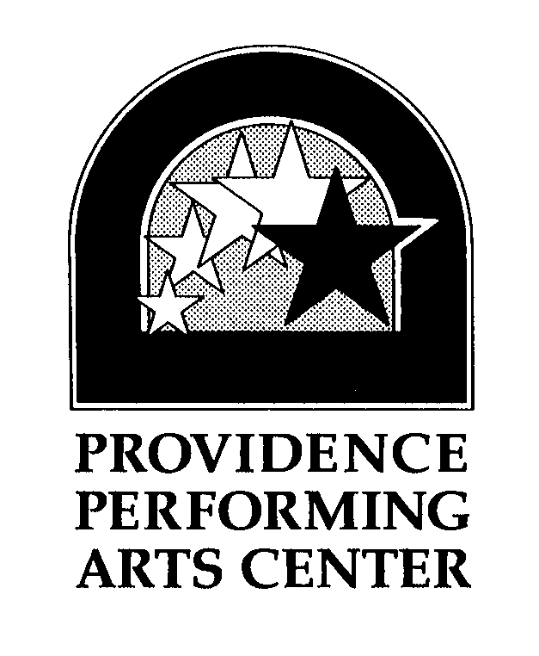
Cocktail Party Menus

President’s Cocktail Party Package………………..…………….…………..$28.50 per person
1 selection from Section A
3 selections from Section B
2 selections from Section C

VP’s Cocktail Party Package…………………..……………………………….$24.00 per person
3 selections from Section B
2 selections from Section C

Section A
- Coconut shrimp with orange marmalade horseradish dipping sauce
- Beef tenderloin on French bread with horseradish cream
- Scallops on tortilla shell with avocado relish
- Skewered tenderloin with horseradish cream
- Smoked chipotle chicken salad on toasted corn bread
- Cocktail shrimp with spicy cocktail sauce
- Lobster cakes with remolade
- Garlic mashed potatoes and lobster crostini with lemon aioli
- Scallop wrapped in hickory smoked bacon

Section B
- Endive boats with crumbled gorgonzola, dried cranberries, and finely diced apples and walnuts
- Stuffed mushrooms
- Assorted grilled pizza
- Grilled vegetable quesadillas with guacamole and salsa
- Phyllo cups with caramelized onion and goat cheese drizzled with balsamic reduction
- Vegetable nime chow with Thai dipping sauce
- Crab cakes with cilantro cream
- Chicken sate with peanut dipping sauce
- Chicken Caesar salad in puff pastry cups
- Smoked salmon with dilled sour cream on lightly toasted crostini

Section C
- Assorted domestic & imported cheese display with French bread and crackers, garnished with seedless grapes
- Seasonal vegetable crudités with sweet red pepper dipping sauce
- Warm artichoke and goat cheese dip
- Trilogy of baked brie with pesto, brown sugar and walnuts, and cranberry and orange zest served with French bread
- White bean and garlic spread with lightly toasted crostini
- Basket of bruschetta with sliced tomatoes and parmesan cheese

